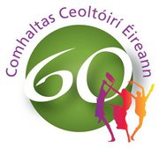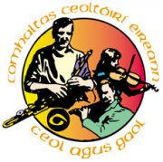

Comhaltas Ceoltóirí Eireann, Craobh Baile an Chabháin
Cavan Town Branch CCE

PHOTOGRAPH CONSENT FORM

As the Cavan Town CCE we feel it is important to recognise the progress, achievements and successes of our youth and of the Branch as a whole. One of the ways to do this is to publish photographs of events, sessions and details of achievements
We take the issue of child safety very seriously and this includes the images of the children in our care. Our duty to our young members is paramount and this form of publicity must be carefully monitored to ensure that it is consistent with our Child Protection Policy and the Data Protection Legislation.

For this reason we have put the following guidelines into place:
- We ask parental consent for the branch to take and use photographs of their children and for permission to use the press and media to promote the youth programme.
- Photographs will at all times take place in the presence of a branch officer.
- We will only use group photographs in the local press, our branch website and through the social media.
- Individual photographs will only be used with individual parental consent prior to the inclusion on the branch website or in the local press.

I have read the conditions of use and consent to my child’s/children’s photograph being used. If there is any change to my decision I will inform the Branch.

Name of child/children: __________________________________________
_________________________________________
Name of parent/guardian: ________________________________________

Signature: __________________________ Date: _______________

