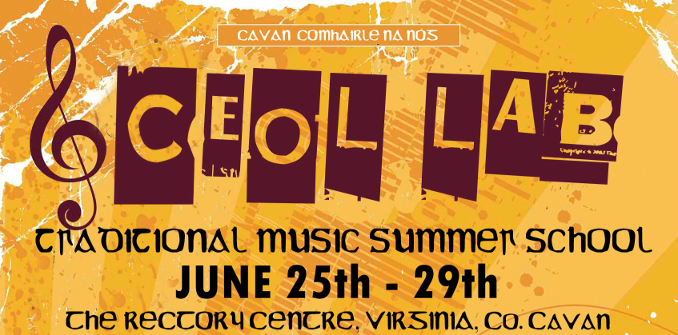

INFORMATION & CONSENT FORM
Please post this signed consent form to the following address before the 21st of June
Breffní Clarke, Community & Enterprise, Cavan Co Council, Farnham St, Cavan

Young Person’s Name: ______________________ Date of Birth: _________________

Address: _________________________________________________________
Comhaltas Group: _________________________________________
Instrument(s) played: ______________________________________
Young Person’s Contact No: _________________________________________
Parent/Guardian Name: ________________________________________
Contact Number (preferably mobile): ________________________________________
Email Address: ________________________________________
Address: _______________________________________________________________
Relationship to Young Person: ________________________________________
(e.g. Mother / Father / Guardian)
Alternative Contact Person (in case of an emergency): ___________________________
Address: ___________________________________________________________
Phone Number (preferably mobile): ____________________________________
Please state if the young person named above suffers from any medical conditions e.g. Asthma, Allergies, Bronchitis, Diabetes, Epilepsy, etc.
________________________________________________________________________
Is he/she taking medication? If yes, please state the type of medication below and ensure that he/she brings it to the Ceol Lab Summer School
________________________________________________________________________
Does he/she have any special dietary requirements? (Nut allergies, Vegetarian etc.)
________________________________________________________________________

ADDRESS & LOCATION: The address of the Rectory Centre is as follows; Beagh, Virginia, Co. Cavan.
It is located approximately halfway between the towns of Virginia and Bailieboro – see red dot on map below.
- Ceol Lab will commence at 13.00 on Monday the 25th of June so please ensure that your child is on site before 12.00 at the latest.
- Ceol Lab will finish with a concert for parents in the adjacent Community Centre on Friday the 29th of June from 6pm to 7pm. Your attendance will be greatly appreciated.
- All food, accommodation and workshop costs are included in the €300 scholarship.

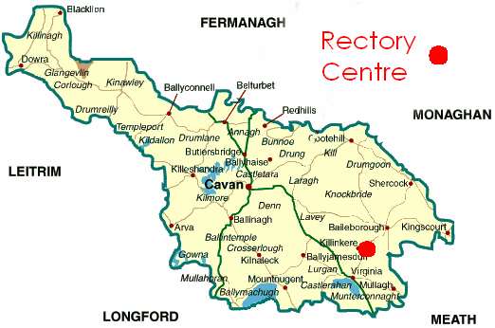

- Participants are asked to contribute €50 euro towards the supervision costs of the week. This must be brought on Monday June 25th. Make cheques out to Cavan Co. Board Comhaltas. Stamped receipts will be posted to each payee.
- The week will be divided into a mixture of music master-classes as well as a range of fun activities.
- A full itinerary of the course will be emailed to parents and participants upon receipt of this signed consent form.
- There will be one adult supervisor present for every eight students throughout the duration of the summer school
- Supervision will be provided 24 hours a day.
- Male & female dorms are located on different floors of the building.

- Participants are required to bring the following items:
- Pillow, towels, quilt or sleeping bag and spare linen covers.
- Adequate clothing for the duration of the summer school. 1 change of old clothing.
- Rain jacket and wellies (we hope it will be sunny throughout but you never can tell!)

Please CIRCLE Yes / No to the following statements

I grant permission for _________________________________ to;
(Young Persons Name)
YES / NO
- Attend the Ceol Lab residential music school from the 25th to the 29th of June

- Be included in any publicity photographs and video shots for the media
YES / NO

Signed: __________________________ Date: ____________________________

Relationship to Young Person (Mother, Father, Guardian etc.) ____________________

If you have any questions please don’t hesitate to contact either Breffní Clarke (Cavan County Council Youth Officer) on 087 122 5465 (bclarke@cavancoco.ie) or Gary Lynch (Ceol Lab Music Coordinator) on 087 253 7814 (glynch@heronmorgan.com)

